CS1150
Using the Debugger

Debugging

Debugging is the process of identifying and removing logical and runtime errors from your code.

Two Different Approaches to Debugging
- Print out values of variables and flow of execution to track down issue
- Use the debugger that comes with your IDE
  - Debuggers allow you to
    - Step through the code one statement at a time
    - Step into or over methods
    - Set breakpoints - a place where the code will stop executing
    - Examine variables - watch variables - modify variables
    - Display the call stack

Using Debugger
- Set a breakpoint
  - In Eclipse:
    - Move cursor to the very left of the line of code - to edge of the edit window
    - Double click
    - A blueish dot will appear to indicate that a breakpoint has been set.
- Start the debugger
  - From Run menu option select debug, or click debug icon

- Now you will be in the Debug perspective
  - Notice the perspective change in the perspective view (on right side of Eclipse)

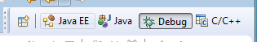

- Now you can watch variables and step through code
- In the window with the code, notice execution is stopped on line with breakpoint.
  - Highlighted line means it has not been executed yet

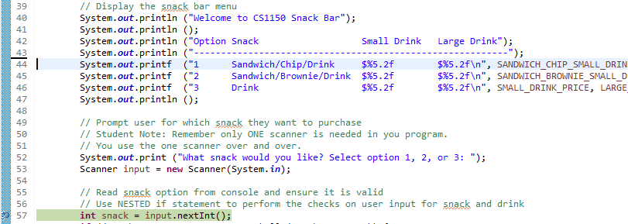

- Now you can “step” through code
  - These two arrows in upper menu allow you to step into and step over code

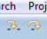

  - You DO NOT want to “step into” the Scanner
  - You want to "step over" the line: int snack = input.nextInt();

  - If you want, you can set things up so you don't step through code that is imported
  - In our case we don't want to debug code from the java.util package
    - Go to Windows -> Preferences -> Java -> Debug -> Step Filtering
    - Check "Use Step Filters"
    - Check the java.*
    - Click "Apply" then "Okay"

Learning the Debugger
- Start off with setting one break point in your code as described above
- Next run the code using the debugger – in Run menu option select Debug

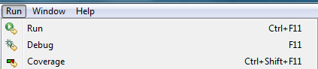
- You might see the following dialog – click “switch

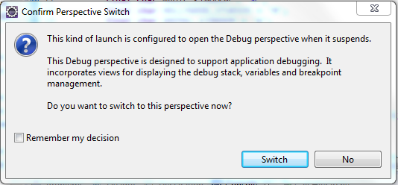

- Next notice where the code is highlighted.
  - I placed a breakpoint on the line where I’m reading the value user enters for the snack

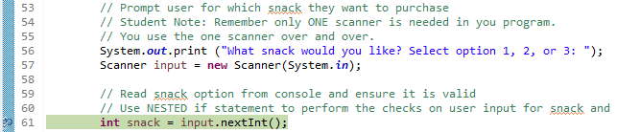
- Now click “step over” icon and notice the code is waiting for you to enter a value in the console just as if I was running it without the debugger. If you click “step over” again nothing happens.
  - Enter a value in the console window to select a destination city
  - Notice how the code now highlighted is the next executable line of code.
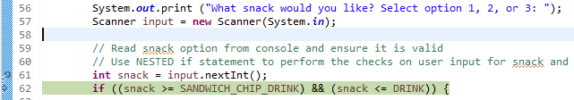
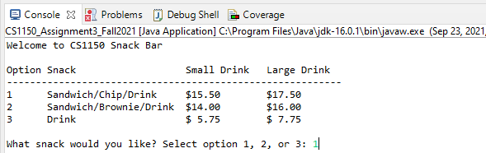

- Also notice in variables window on right, snack variable now appears and contains the value 1

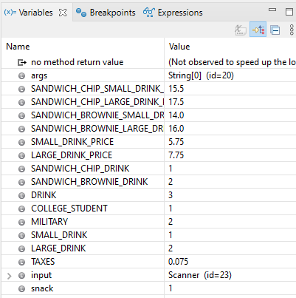
- To get out of the debugger, on the right side or the window, click the Java perspective icon. The selected icon is the debug perpective.

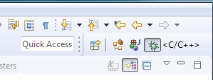 | The current selected icon is the debug perspective.

- Also be sure your program has terminated.
  - If you still see the red box in the console window, it means the code is still running.
  - When the code is running there is a process in the task manager that is running.
  - Be sure to terminate the code before running it again otherwise you will be starting a new process on top of the process that is currently running.

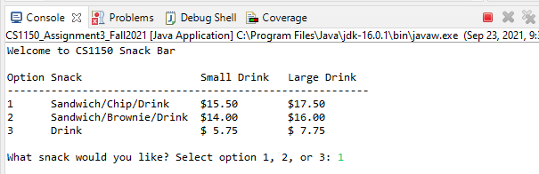

  - This code is NOT running – box is no longer red
